The Youth Employment and Training Programme (YETP) of the Labour Department
- YETP of the Labour Department provides a comprehensive platform of job search with one-stop and diversified pre-employment and on-the-job training for young school leavers aged 15 to 24 with educational attainment at sub-degree level or below. It enables young people to better understand themselves and their work aptitudes while enriching their job skills and experience so as to enhance their employability.

 | True Story Behind the Scene
Silky TANG |  | YETP trainees
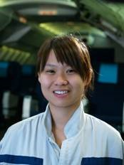 | Silky joined YETP in 2007. She is now an Aircraft Maintenance Approved Technician in an aircraft engineering company. She was also one of the Most Improved Trainees (MIT) of YETP in 2008.  After completed Form 5, Silky worked as a sales executive for about a year. Silky is interested in assembling and disassembling mechanical devices since childhood. One day, she came across an online advertisement of YETP about the "Aircraft Maintenance Craftsman Trainee" Training Project. She applied without any delay in the hope of becoming an Aircraft Maintenance expert.
At the beginning, Silky hesitated if she was able to discharge the duties as she was the only girl in the department. However, after an intensive pre-employment training, Silky was successfully employed as an Aircraft Maintenance Craftsman Trainee. Upon employment, Silky encountered lots of difficulties at work as the job required physical strength. Nevertheless, she did not give up and strived hard to overcome challenges. While repairing work generally required compliance with instructions and procedures, Silky sometimes had arguments with her supervisors due to different points of views. Silky was grateful to the guidance and support from her mentor and co-workers, so that she finally learnt how to respect others and appreciate the precious experience shared by supervisors. This facilitated a harmonious working relationship with her teammates.
Even Silky is busy at work, she keeps on taking further studies on aircraft maintenance to achieve her career goal as Aircraft Engineer. Having promoted to Aircraft Maintenance Tradesman (Grade 2) last year, Silky got promoted again this year as an Aircraft Maintenance Approved Technician and moved closer to her career goal.

 | True Story Behind the Scene
Billy Ho Chun-wai |  | YETP trainees
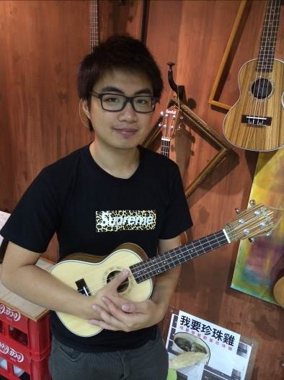 | Billy joined YETP in 2007. He is now a co-founder of a private music school. Billy was also one of the Most Improved Trainees (MIT) of YETP in 2008.  Billy is interested in music and started learning piano since childhood. When he was studying in Form 4, he went to Canada and graduated from a high school. He completed a one-year preparatory course in a community college. Though Billy had planned to study accounting in a university in the light of his satisfactory academic results, he was not interested in accounting in fact and was worried about the financial burden on his mother if he stayed overseas. Billy finally decided to return to Hong Kong and look for a job.
At that time, Billy had no idea on his way forward. Coincidentally, Billy came across with a recruitment advertisement of YETP about a Club Assistant Training Project. He applied and was employed. As a newcomer, Billy was passive and quiet at work. However, with the assistance of his mentor and other colleagues, he adapted to the working environment with a humble heart and built a good relationship with the residents and colleagues quickly. Besides, Billy was invited to be a guest pianist of his club house when his supervisor learnt about his Grade 8 piano qualification incidentally. His performance was highly appreciated by the residents. Since Billy still wanted to develop his career in music, he changed to work as a part-time staff in the club house and enrolled on a Diploma of Music Composition in Hong Kong International Institute of Music. Later he was employed as a part-time music tutor by a private music school. After four and a half years’ part time work and study, Billy completed the Diploma of Music Composition.
After graduated from Hong Kong International Institute of Music, Billy continued to teach ukulele and djembe in the music school. In 2014, Billy started his own business with a friend and set up a private music school teaching ukulele. Billy was striving for his career in music step by step. Billy remarked that he was so happy knowing his students enjoyed playing music. He believes that helping others to learn and enjoy music is more important than anything else.

 | True Story Behind the Scene
Johnny Choi Yee-tak |  | YETP trainees
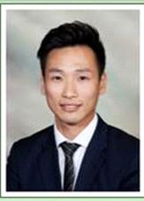 | Johnny joined YETP in 2002. He is now a Sports Officer in a prestigious club.  When Johnny, a typical sport lover, studied in junior secondary curriculum, he had no interest in studying and his academic performance was far from satisfactory. He changed school in Form 4 due to poor results. He finished Form 5 studies but his academic results in HKCEE were unsatisfactory, neither have any study nor career plan. During that period, Johnny had worked as an assistant in the Internet Café temporarily. Later, as introduced by friends, he found a part-time job assisting in organising activities and undertaking clerical duties.
Johnny joined the YETP with his friends. He built up confidence and set his goals through the training courses. Under the recommendation of the case manager, Johnny was also offered an on-the-job training opportunity related to recreational activities. Such on-the-job training opportunity brought an invaluable experience to Johnny’s life. It also mapped out Johnny’s career plan and helped him build up a solid foundation.
Upon completion of 1-year on-the-job training, Johnny was employed as a Recreation Assistant, a job that he had failed in interview one year ago. Over the period, his seniors and the General Manager provided much support and opportunities to Johnny who was promoted to Senior Recreation Officer. He also finished a Diploma Course in Sport and Recreation Management and completed a Degree Course in Marketing. During his leisure time, he worked as a part-time gym instructor as well as soccer coach in his secondary school.
Johnny is now a Sports Officer in a prestigious club, responsible for monitoring all sport activities and facilities in the club. Johnny plans to enroll on the Master’s Degree Course in Hospitality Management, striving for excellence to become a General Manager in the near future.

 | True Story Behind the Scene
Stephen To Kwok-shing |  | YETP trainees
Stephen joined YETP in 1999. He is now a Centre-in-charge of a social welfare organisation providing services to children and the youth.
Failed in the HKCEE, Stephen joined YETP. With the concerted efforts of the instructors in the YETP, Stephen started to think about his future and plan his career path. He once decided to go back to school but his academic results in HKALE were unsatisfactory. Stephen then joined the on-the-job training of YETP, his performance was recognised by the supervisor and confidence has been restored.
Through the above experience, Stephen gradually identified his goals. He realised that personal ability, academic qualifications and working experience were essential to acquire an ideal job. Stephen was inspired to work harder. Based on his participation in voluntary work in secondary school, Stephen found out that he was fond of meaningful and people-oriented nature of work. He then determined to join the social service sector and was finally admitted to study social work in university.
After acquiring the Bachelor’s Degree in Social Work, Stephen joined a social welfare organisation. His major service target was teenagers and he became a case manager of YETP. As Stephen had similar experience as the teenagers he was serving, he could better understand them and offered more support to them. Stephen is now a Centre-in-Charge responsible for supervising other social workers (including case managers of YETP) as well as centre planning and development. Stephen undertook part-time studies and graduated from a Master of Arts Programme in Family Counselling and Family Education.
Stephen thought that the most difficult time in his life was Form 5 graduation because he was very confused with his future. He was grateful having joined YETP through which he not only acquired computer skills and sports qualifications, but also received guidance from instructors and supervisors. All these changed his life planning and contributed to his achievements.

− END −

